Core Java Assignment – Ette Divya Nikitha
- Given:
public class TaxUtil {
double rate = 0.15;

public double calculateTax(double amount) {
return amount * rate;
}
}
Would you consider the method calculateTax() a 'pure function'? Why or why not?
If you claim the method is NOT a pure function, please suggest a way to make it pure

No, calculateTax() method is not a pure function because it depends on the variable rate and rate is defined outside the method. So the value of the variable rate can be changed by another method.
To make it pure - make the function depend only on its parameters.
public class TaxUtil {
public double calculateTax(double amount, double rate) {
return amount * rate;
}
}
2)What will be the output for following code?
class Super
{
static void show()
{
System.out.println("super class show method");
}
static class StaticMethods
{
void show()
{
System.out.println("sub class show method");
}
}
public static void main(String[]args)
{
Super.show();
new Super.StaticMethods().show();
}
}

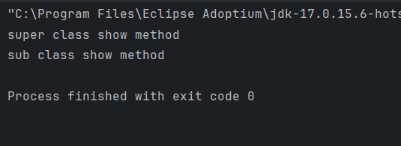
3)
What will be the output for the following code?
class Super
{
int num=20;
public void display()
{
System.out.println("super class method");
}
}
public class ThisUse extends Super
{
int num;
public ThisUse(int num)
{
this.num=num;
}
public void display()
{
System.out.println("display method");
}
public void Show()
{
this.display();
display();
System.out.println(this.num);
System.out.println(num);
}
public static void main(String[]args)
{
ThisUse o=new ThisUse(10);
o.show();
}
}
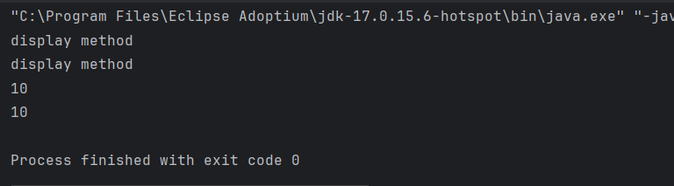
4) What is the singleton design pattern? Explain with a coding example.
The Singleton Design Pattern ensures that only one instance of a class is created throughout the entire application, and provides a global point of access to that instance.
Useful when exactly one object is needed

public class Singleton {

private static Singleton instance;

private Singleton() {
System.out.println("Singleton instance created.");
}

public static Singleton getInstance() {
if (instance == null) {
instance = new Singleton(); // only created once
}
return instance;
}

public void showMessage() {
System.out.println("Hello!");
}
}

5) How do we make sure a class is encapsulated? Explain with a coding example.
Encapsulation is the object-oriented principle of hiding internal data and restricting direct access to it. Instead, access is provided via public getter and setter methods.
To make a class fully encapsulated, Declare all variables as private and Provide public getter and setter methods to access and update them.
public class Student {
private String name;
private int age;
public String getName() {
return name;
}
public void setName(String name) {
this.name = name;
}
public int getAge() {
return age;
}
}
}
6)Perform CRUD operation using ArrayList collection in an EmployeeCRUD class for the below Employee
class Employee{
private int id;
private String name;
private String department;
}

https://github.com/divyaette/rg-assignments/tree/feature-java/src

7) Perform CRUD operation using JDBC in an EmployeeJDBC class for the below Employee
class Employee{
private int id;
private String name;
private String department;
}
